ASTRA INTERIORS
Mr. Manoker – Wardrobe cut list (4 bedrooms)
Date: 11-11-2026
Wardrobe | Width | Height | Cupboard box | Loft | Pieces | 18 mm sheets | 6 mm sheets | LED strip
GF Bedroom | 2526 | 2857 | 2000 mm | 90 mm frame, 857 H | 59 | 5 | 3 | 3 pcs / 4.92 m
1st Floor M.Bedroom | 2349 | 2905 | 2000 mm | 90 mm frame, 905 H | 53 | 5 | 2 | 3 pcs / 4.87 m
1st Floor Bedroom 2 | 2319 | 2895 | 2000 mm | 90 mm frame, 895 H | 53 | 5 | 3 | 3 pcs / 4.48 m
2nd Floor Bedroom | 2349 | 2825 | 2000 mm | 90 mm frame, 825 H | 53 | 5 | 3 | 3 pcs / 4.48 m

- Board: 18 mm ply for all carcass, shelves and drawers. Back panels: 6 mm ply OUTER TO OUTER, 2000 high, screwed on the back edges (no groove); joints on partition centres.
- Depth: all wardrobes 500 total = carcass 494 (side / top / bottom / full-height partitions, doors are fixed on them) + 6 mm back. Inside partitions (dressing / bangle column) = 494. Shelves = 474 (set back 20 mm).
- Every wardrobe is a CUPBOARD BOX 2000 mm high (an 8 ft ply sheet is only 2400 mm long).
- LOFT above the cupboard = 90 mm FRAME ONLY: 90 mm uprights at the ends and partitions + 90 mm top and bottom rails. No loft box, no loft back panel. Loft floor = cupboard top panel.
- GF Bedroom is wider than 2400 mm, so it has 2 cupboard boxes side by side and the loft rails are in 2 pieces – no piece is longer than 2400 mm.
- LED strip-light groove: one vertical groove per cupboard section, 12 mm wide × 8 mm deep, 100 mm from the front edge, on the side / partition face.
- Drawers: bottom 2 drawers only in every bedroom, opening 173, drawer box 150 high. 18 mm frame (sides + front/back inner) with an 8 mm wide x 10 mm deep groove: leave 12 mm from the bottom edge, groove from 12 to 20 mm; the 6 mm drawer bottom slides into the groove (size = inside + 18 mm: 10 mm groove each side, 1 mm play).
- Cut L / Cut W = panel-saw size (front edge minus 0.5 mm edge tape). Add saw kerf when marking out.
- Shutters: 5 doors per bedroom (2 + 1 + 2, centre door = dressing; GF centre door glass with 90 border), 18 mm ply + laminate, full overlay; gaps 2 mm between doors, 3 mm next to side cover / strip, 2 mm cupboard-to-loft door, 1 mm bottom and top; 2 mm edge tape on 4 sides (Cut = finished - 4 mm). Drawer section: doors only above the drawers; the 2 drawers have outside fronts in shutter material.

GF Bedroom wardrobe
2526 W × 2857 H × 500 D · cupboard box 2000 mm + loft 90 mm frame only · cupboard clear 1884 mm
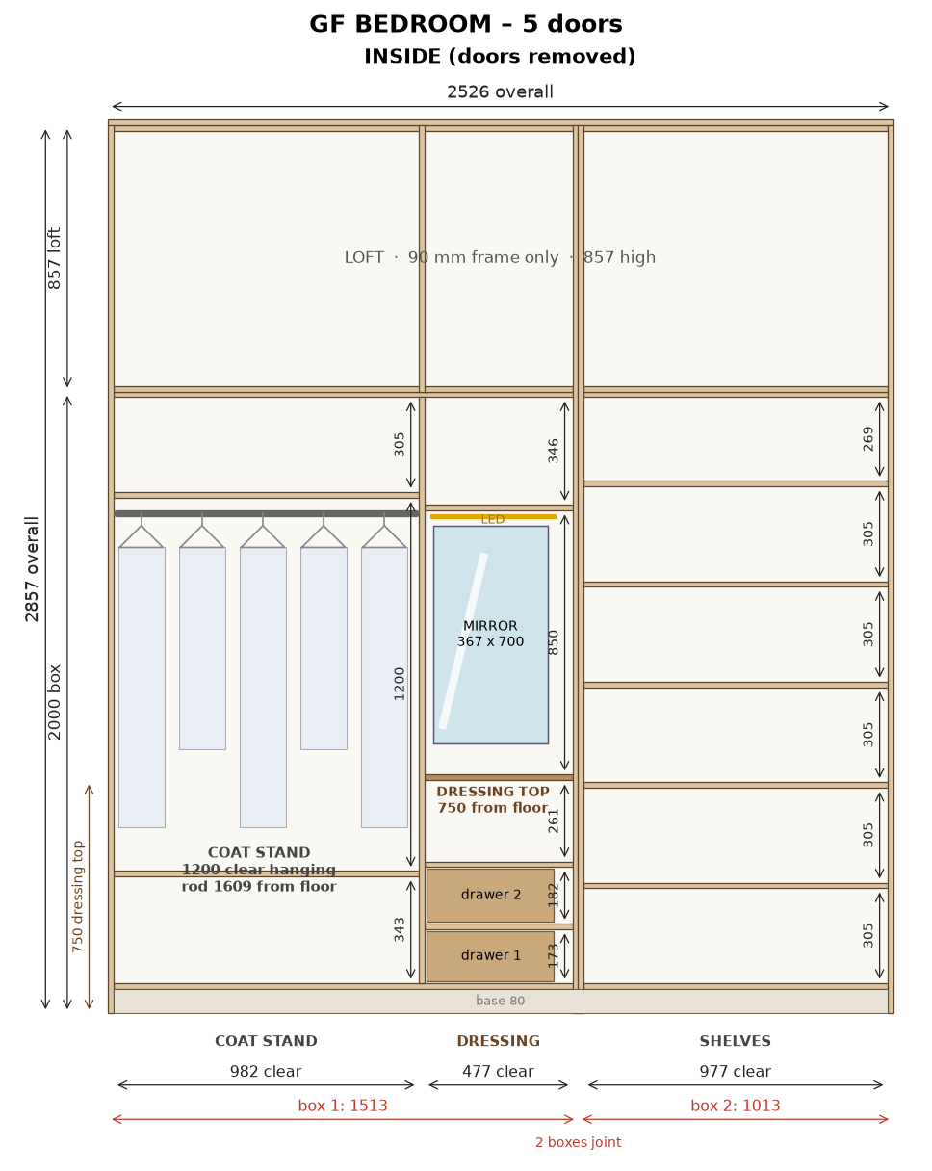
2D drawing (owner's AutoCAD): cupboard box 2000 mm high; loft above = 90 mm frame only (uprights + top/bottom rails). LED strip groove in each cupboard section.

GF Bedroom – shutters with Merino laminate
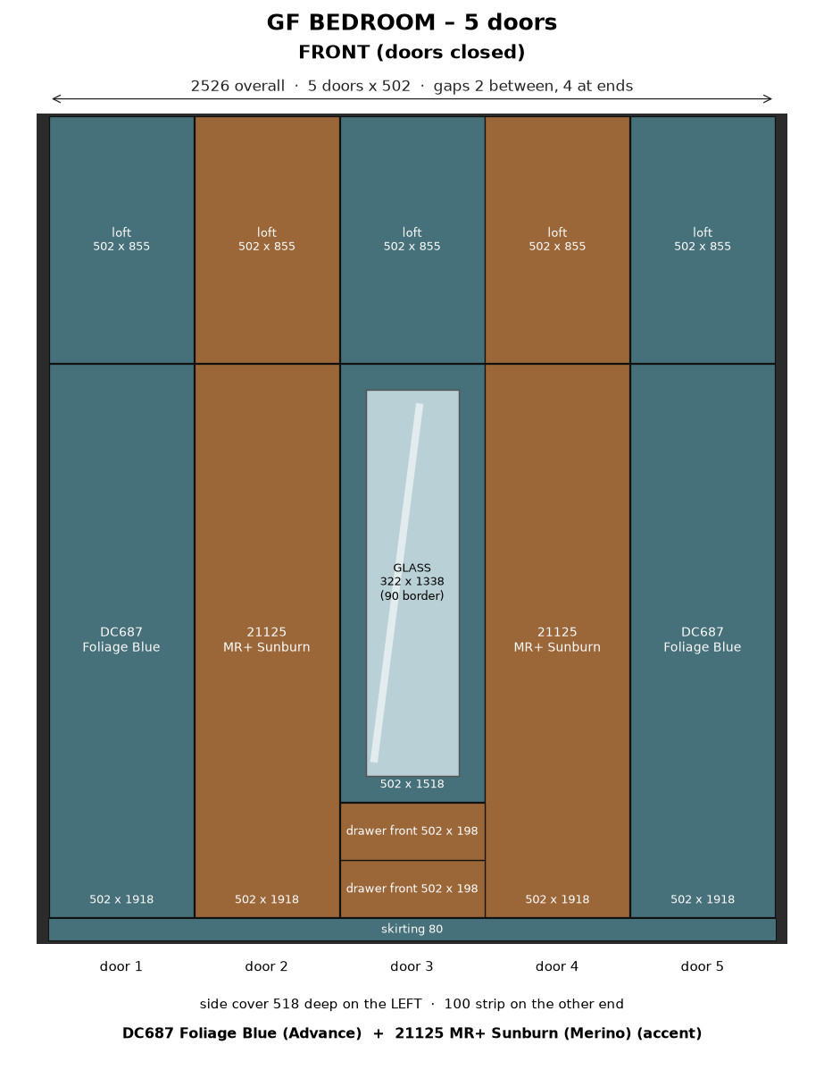

GF Bedroom – 3D model – assembled box without doors (off-white carcass, LED strips, drawer fronts)
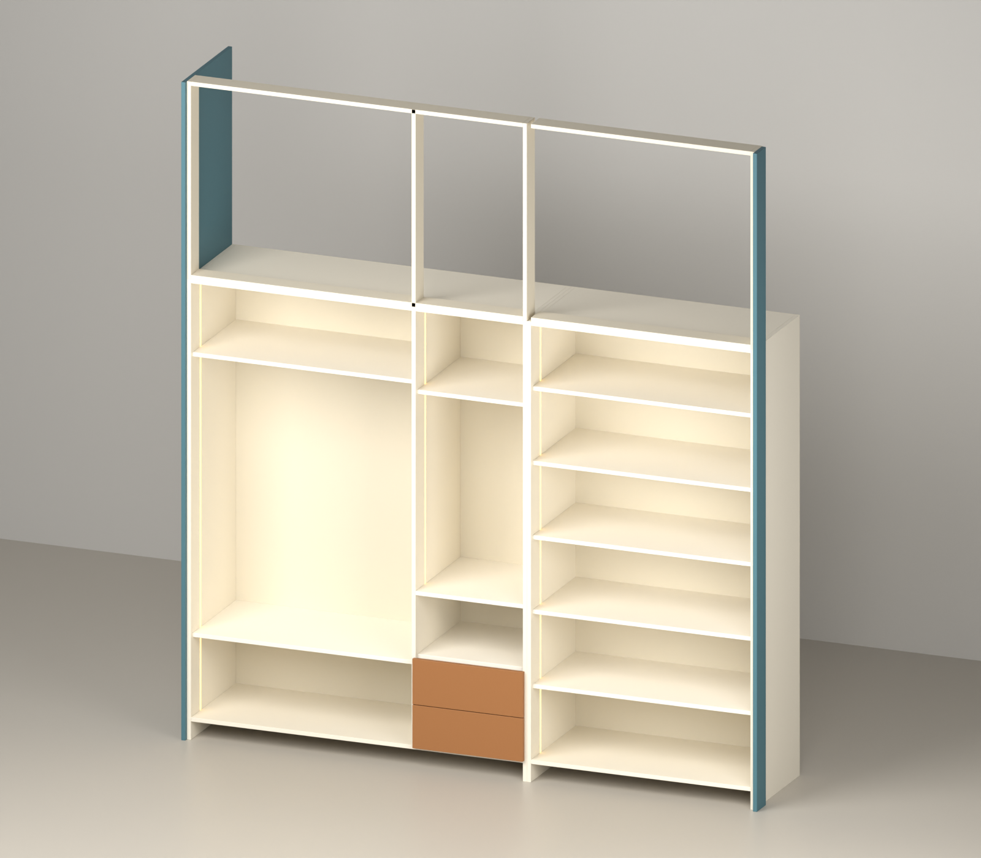

GF Bedroom – 3D model – exploded view of the pieces
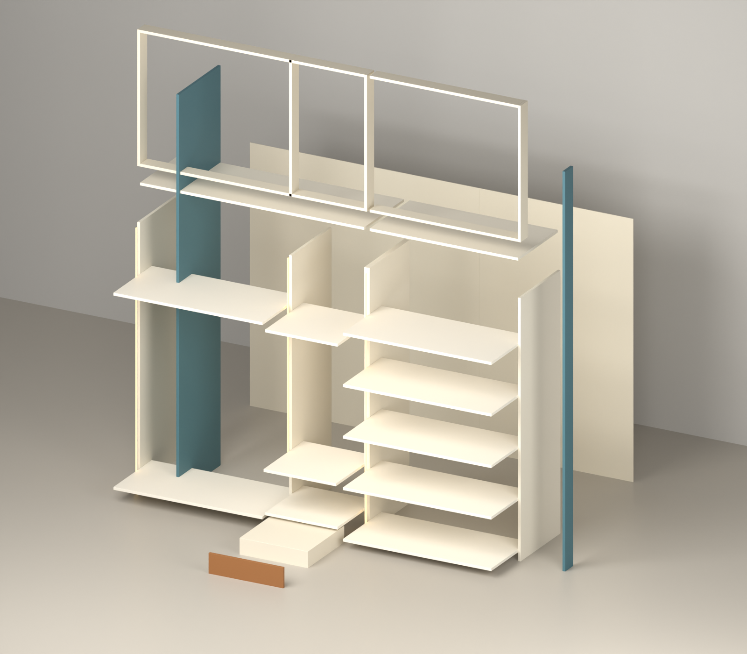

GF Bedroom – All pieces drawn to scale – # = row number in the cut list
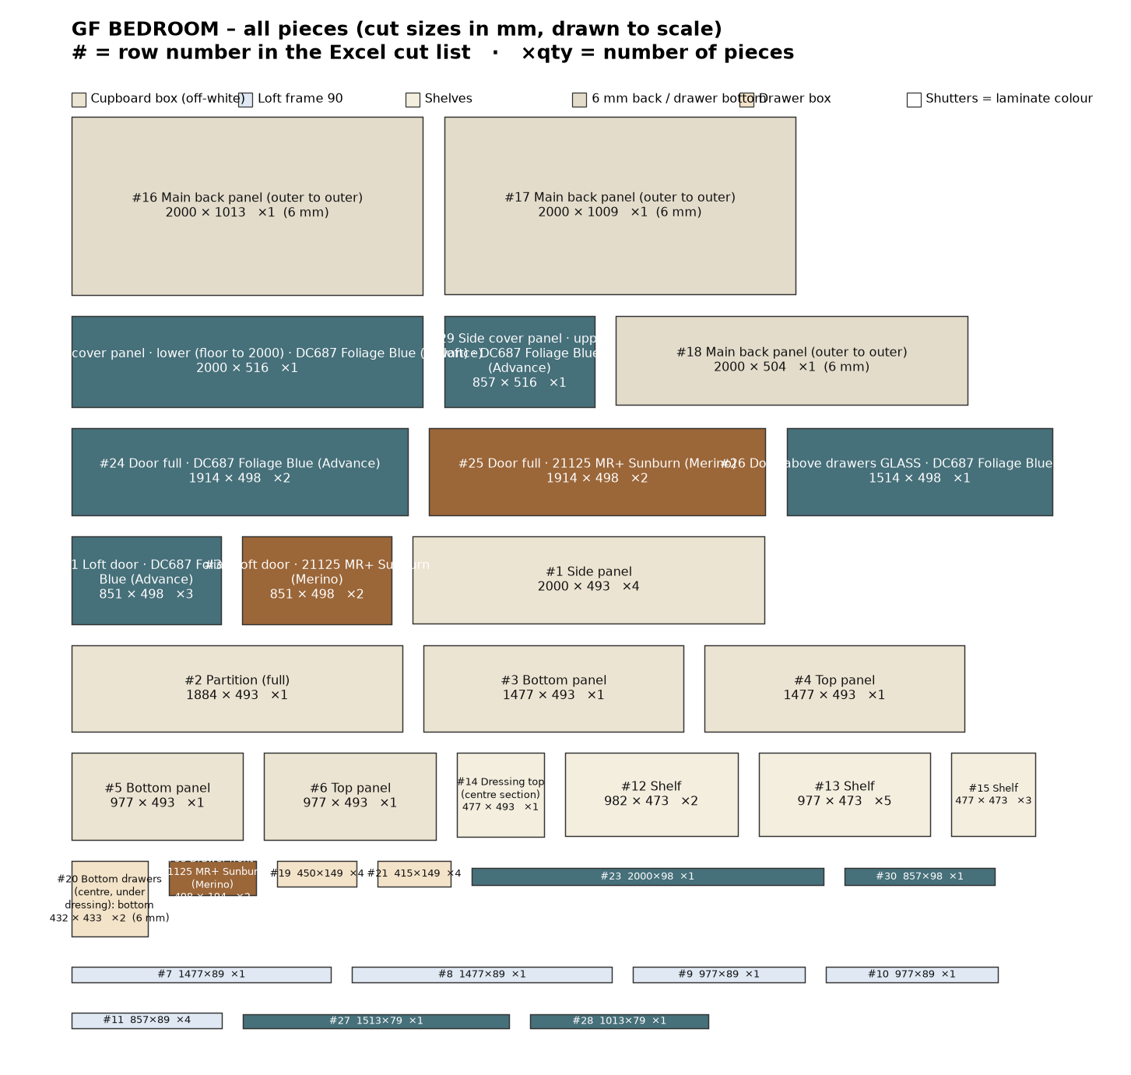

GF Bedroom wardrobe – cut list
# | Group | Part | Material | Qty | Finished L | Finished W | Cut L | Cut W | Edge band | Machining / note
Cupboard box
1 | Cupboard box | Side panel (cupboard, 2000 high) | 18 mm ply | 4 | 2000 | 494 | 2000 | 493 | 0.5 mm, 1 long | 6 mm back screwed on back edge
2 | Cupboard box | Partition (full height, doors fixed) | 18 mm ply | 1 | 1884 | 494 | 1884 | 493 | 0.5 mm, 1 long | back panel joint on its back edge (centre)
3 | Cupboard box | Bottom panel | 18 mm ply | 1 | 1477 | 494 | 1477 | 493 | 0.5 mm, 1 long
4 | Cupboard box | Top panel | 18 mm ply | 1 | 1477 | 494 | 1477 | 493 | 0.5 mm, 1 long
5 | Cupboard box | Bottom panel | 18 mm ply | 1 | 977 | 494 | 977 | 493 | 0.5 mm, 1 long
6 | Cupboard box | Top panel | 18 mm ply | 1 | 977 | 494 | 977 | 493 | 0.5 mm, 1 long
Loft frame 90 mm
7 | Loft frame 90 mm | Top rail | 18 mm ply | 1 | 1477 | 90 | 1477 | 89 | 0.5 mm, 1 long | fix to ceiling
8 | Loft frame 90 mm | Bottom rail (front, on cupboard top) | 18 mm ply | 1 | 1477 | 90 | 1477 | 89 | 0.5 mm, 1 long
9 | Loft frame 90 mm | Top rail | 18 mm ply | 1 | 977 | 90 | 977 | 89 | 0.5 mm, 1 long | fix to ceiling
10 | Loft frame 90 mm | Bottom rail (front, on cupboard top) | 18 mm ply | 1 | 977 | 90 | 977 | 89 | 0.5 mm, 1 long
11 | Loft frame 90 mm | Frame upright (end / partition) | 18 mm ply | 4 | 857 | 90 | 857 | 89 | 0.5 mm, 1 long | loft frame only - no box, no back panel
Inside
12 | Inside | Shelf | 18 mm ply | 2 | 982 | 474 | 982 | 473 | 0.5 mm, 1 long
13 | Inside | Shelf | 18 mm ply | 5 | 977 | 474 | 977 | 473 | 0.5 mm, 1 long
14 | Inside | Dressing top (centre section) | 18 mm ply | 1 | 477 | 494 | 477 | 493 | 0.5 mm, 1 long | flush with front (behind door 3); top 750 from floor; mirror + LED above
15 | Inside | Shelf | 18 mm ply | 3 | 477 | 474 | 477 | 473 | 0.5 mm, 1 long
Back panels 6 mm
16 | Back panels 6 mm | Main back panel (outer to outer) | 6 mm back ply | 1 | 2000 | 1013 | 2000 | 1013 | - | screw on back edges of sides / top / bottom / partitions; joint on partition centre
17 | Back panels 6 mm | Main back panel (outer to outer) | 6 mm back ply | 1 | 2000 | 1009 | 2000 | 1009 | - | screw on back edges of sides / top / bottom / partitions; joint on partition centre
18 | Back panels 6 mm | Main back panel (outer to outer) | 6 mm back ply | 1 | 2000 | 504 | 2000 | 504 | - | screw on back edges of sides / top / bottom / partitions; joint on partition centre
Drawers
19 | Drawers | Bottom drawers (centre, under dressing): drawer side | 18 mm ply | 4 | 450 | 150 | 450 | 149 | 0.5 mm, 1 long | groove 8 mm wide x 10 deep: leave 12 mm from bottom edge, groove 12-20 mm (6 mm drawer bottom slides in)
20 | Drawers | Bottom drawers (centre, under dressing): drawer bottom 6 mm (in groove) | 6 mm back ply | 2 | 432 | 433 | 432 | 433 | - | inside size + 9 mm each side (10 mm groove, 1 mm play)
21 | Drawers | Bottom drawers (centre, under dressing): drawer front/back inner | 18 mm ply | 4 | 415 | 150 | 415 | 149 | 0.5 mm, 1 long | groove 8 mm wide x 10 deep: leave 12 mm from bottom edge, groove 12-20 mm (6 mm drawer bottom slides in)
Shutters
22 | Shutters | Side cover panel - lower (floor to 2000) - DC687 Foliage Blue (Advance) | 18 mm ply + Merino laminate (shutter) | 1 | 2000 | 518 | 2000 | 516 | 2 mm, 1 long | LEFT end only, outside of side panel; 518 deep = box 500 + door 18; joint in line with door gap
23 | Shutters | Wall-side strip 100 - lower (floor to 2000) - DC687 Foliage Blue (Advance) | 18 mm ply + Merino laminate (shutter) | 1 | 2000 | 100 | 2000 | 98 | 2 mm, 1 long | RIGHT end, outside of side panel at the front (flush with door front); joint in line with door gap
24 | Shutters | Door (full height) - DC687 Foliage Blue (Advance) | 18 mm ply + Merino laminate (shutter) | 2 | 1918 | 502 | 1914 | 498 | 2 mm, 4 sides | concealed hinges; gaps: 2 mm between doors, 3 mm at end, 1 mm bottom, 2 mm to loft door
25 | Shutters | Door (full height) - 21125 MR+ Sunburn (Merino) | 18 mm ply + Merino laminate (shutter) | 2 | 1918 | 502 | 1914 | 498 | 2 mm, 4 sides | concealed hinges; gaps: 2 mm between doors, 3 mm at end, 1 mm bottom, 2 mm to loft door
26 | Shutters | Door above drawers GLASS - DC687 Foliage Blue (Advance) | 18 mm ply + Merino laminate (shutter) | 1 | 1518 | 502 | 1514 | 498 | 2 mm, 4 sides | CENTRE GLASS DOOR: CNC cut-out 322 x 1338 after laminate + edge band (90 border all round); glass 342 x 1358 fixed behind with beading; concealed hinges; gaps: 2 mm between doors, 3 mm at end, 1 mm bottom, 2 mm to loft door
27 | Shutters | Skirting (front, base 80) - DC687 Foliage Blue (Advance) | 18 mm ply + Merino laminate (shutter) | 1 | 1513 | 80 | 1513 | 79 | 0.5 mm, 1 long | full base height 80 (doors start 1.5 above); 0.5 mm tape on top edge only
28 | Shutters | Skirting (front, base 80) - DC687 Foliage Blue (Advance) | 18 mm ply + Merino laminate (shutter) | 1 | 1013 | 80 | 1013 | 79 | 0.5 mm, 1 long | full base height 80 (doors start 1.5 above); 0.5 mm tape on top edge only
29 | Shutters | Side cover panel - upper (loft) - DC687 Foliage Blue (Advance) | 18 mm ply + Merino laminate (shutter) | 1 | 857 | 518 | 857 | 516 | 2 mm, 1 long | LEFT end only, outside of side panel; 518 deep = box 500 + door 18; joint in line with door gap
30 | Shutters | Wall-side strip 100 - upper (loft) - DC687 Foliage Blue (Advance) | 18 mm ply + Merino laminate (shutter) | 1 | 857 | 100 | 857 | 98 | 2 mm, 1 long | RIGHT end, outside of side panel at the front (flush with door front); joint in line with door gap
31 | Shutters | Loft door - DC687 Foliage Blue (Advance) | 18 mm ply + Merino laminate (shutter) | 3 | 855 | 502 | 851 | 498 | 2 mm, 4 sides | on loft frame; same width as doors below; 2 mm to cupboard door, 1 mm at top
32 | Shutters | Loft door - 21125 MR+ Sunburn (Merino) | 18 mm ply + Merino laminate (shutter) | 2 | 855 | 502 | 851 | 498 | 2 mm, 4 sides | on loft frame; same width as doors below; 2 mm to cupboard door, 1 mm at top
33 | Shutters | Drawer outside front - 21125 MR+ Sunburn (Merino) | 18 mm ply + Merino laminate (shutter) | 2 | 502 | 198 | 498 | 194 | 2 mm, 4 sides | fix on drawer box; handle
 |  | Total pieces |  | 59

Material | Area sq.ft / length | 8×4 sheets (15% waste) | Hardware / item
18 mm ply | 137.1 | 5 | LED strip light + aluminium profile (in grooves): 3 pcs, 4.92 m total
6 mm back ply | 58.4 | 3 | LED driver + door sensor switch: 1
18 mm ply + Merino laminate (shutter) | 96.1 | 4 | Soft-close telescopic channels 450 mm (pairs): 2
Edge tape 0.5 mm (front edges) | 42 m |  | Drawer handles / profile: 2
Edge tape 2 mm (shutters, 4 sides) | 51 m |  | Concealed soft-close hinges (doors): 34
 |  |  | Door handles: 5
 |  |  | Dressing mirror 5 mm (on back panel), 367 x 700: 1
 |  |  | Coat stand: oval SS hanging rod 980 long + 2 end brackets (rod 1609 from floor, 1200 hanging): 1
 |  |  | Glass panel for centre door 342 x 1358 (type to confirm) + beading: 1

LED strip light – profile groove cutting
Groove 12 mm wide × 8 mm deep, 100 mm from the front edge, vertical, on the panel face inside the section. Start is measured from the top of the bottom panel; groove runs up to the underside of the top panel. Drill a 10 mm wire hole through the top panel at the groove top. Keep shelf screws clear of the groove.
Section | Opening W | Panel | Groove on | From front | Groove start | Groove length | Profile + strip
1 | 982 | Side panel | right face (inside section) | 100 mm | 0 mm | 1884 mm | 1864 mm
2 | 477 | Partition | right face (inside section) | 100 mm | 670 mm (above drawers) | 1214 mm | 1194 mm
3 | 977 | Side panel | right face (inside section) | 100 mm | 0 mm | 1884 mm | 1864 mm
Total |  |  |  |  |  |  | 4.92 m

1st Floor M.Bedroom wardrobe
2349 W × 2905 H × 500 D · cupboard box 2000 mm + loft 90 mm frame only · cupboard clear 1884 mm
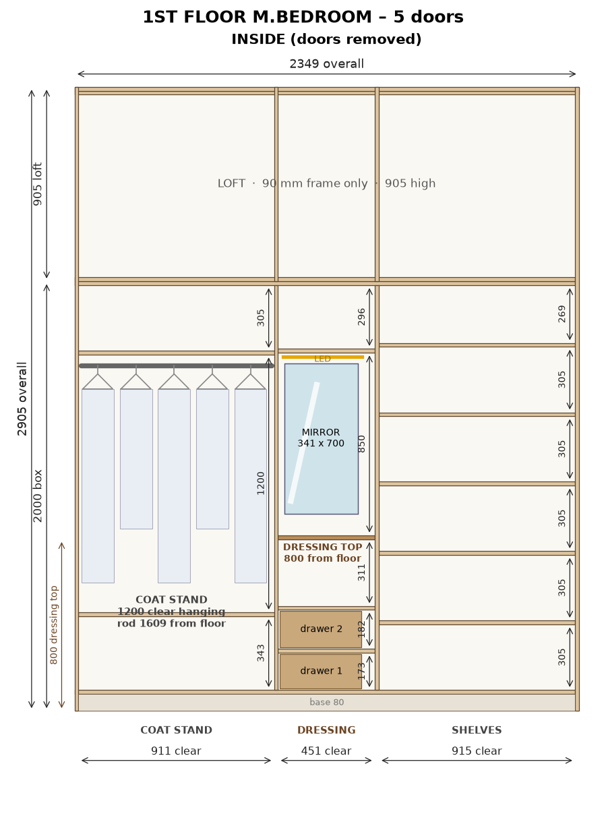
2D drawing (owner's AutoCAD): cupboard box 2000 mm high; loft above = 90 mm frame only (uprights + top/bottom rails). LED strip groove in each cupboard section.

1st Floor M.Bedroom – shutters with Merino laminate
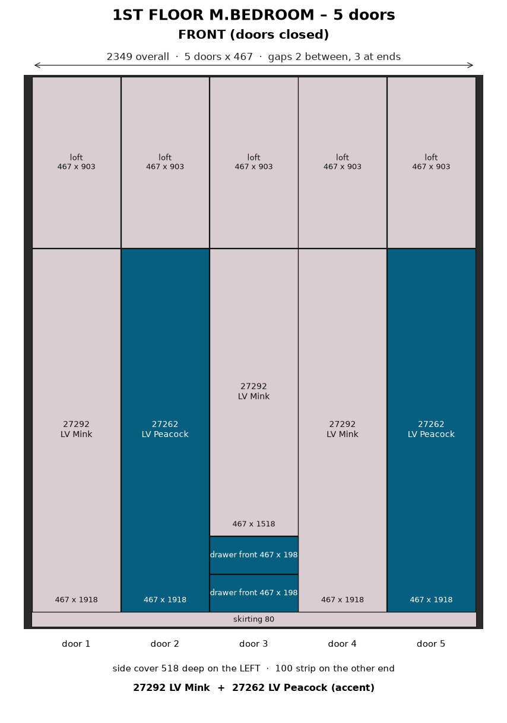

1st Floor M.Bedroom – 3D model – assembled box without doors (off-white carcass, LED strips, drawer fronts)
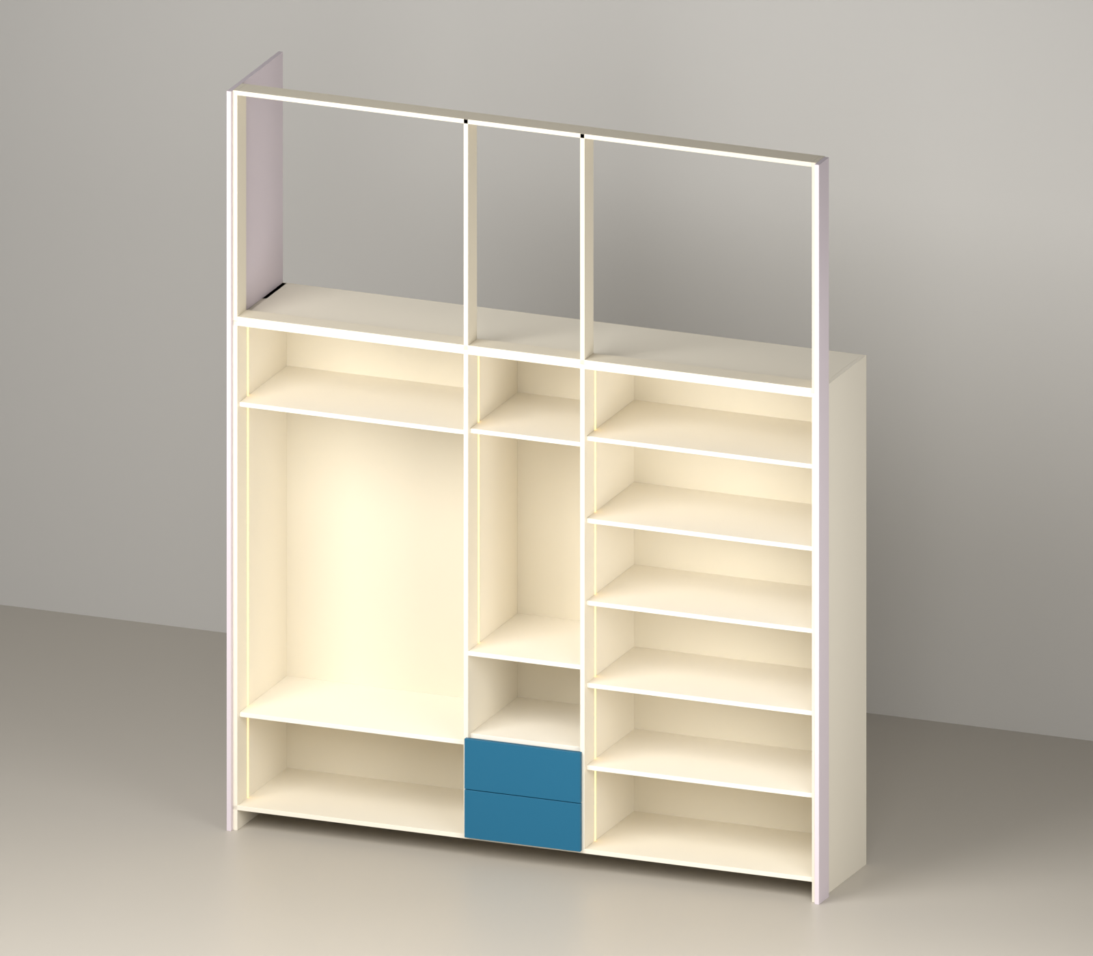

1st Floor M.Bedroom – 3D model – exploded view of the pieces
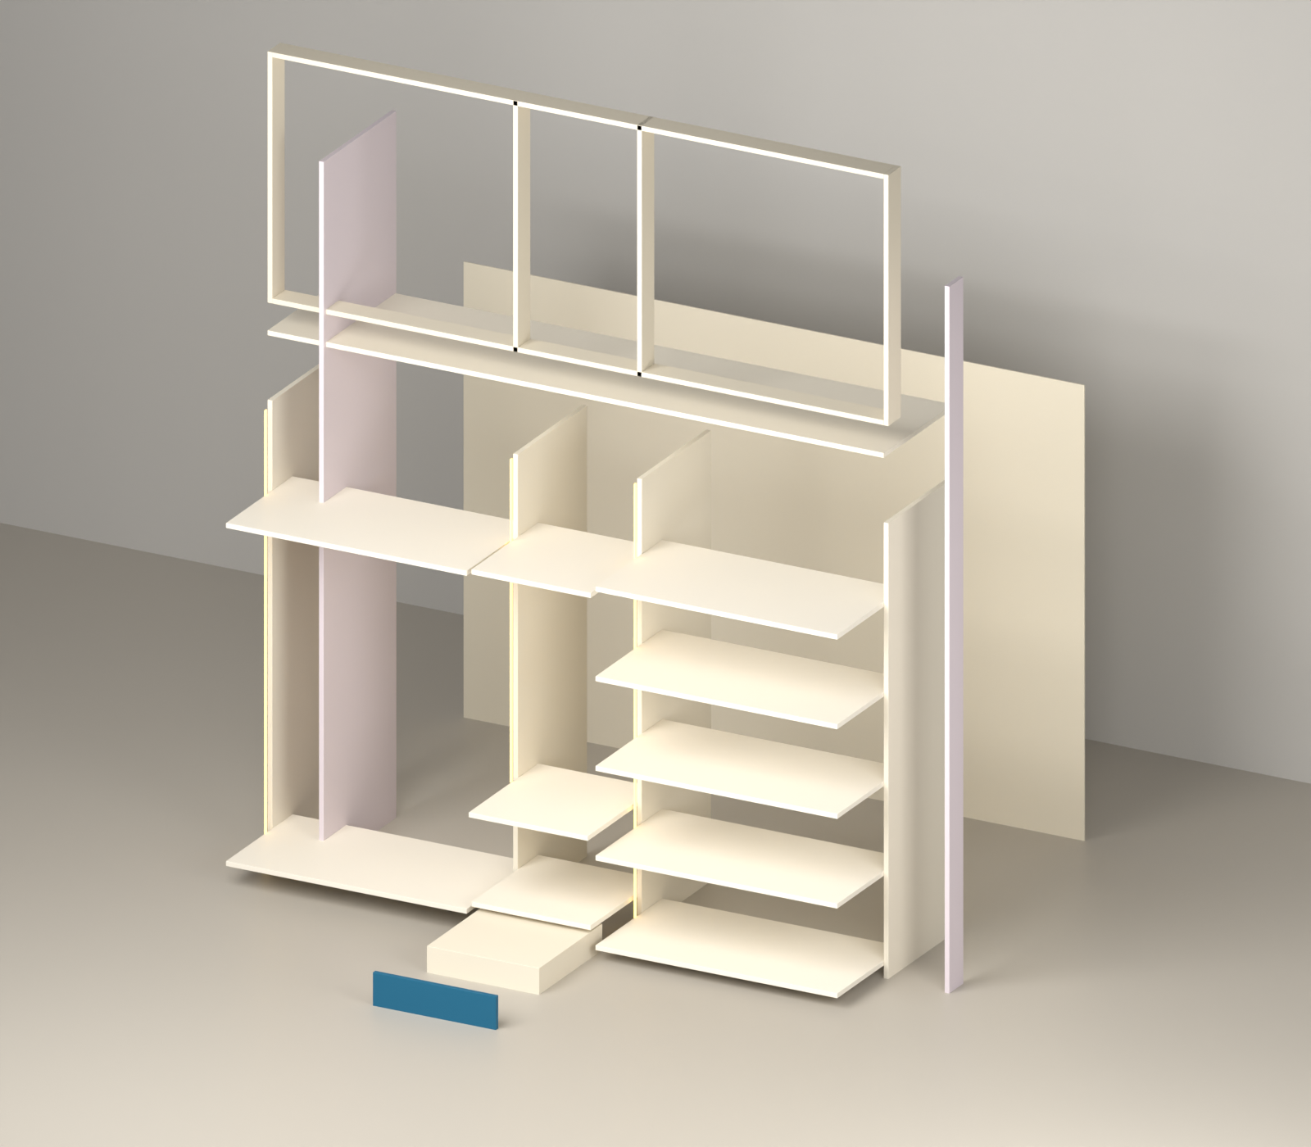

1st Floor M.Bedroom – All pieces drawn to scale – # = row number in the cut list
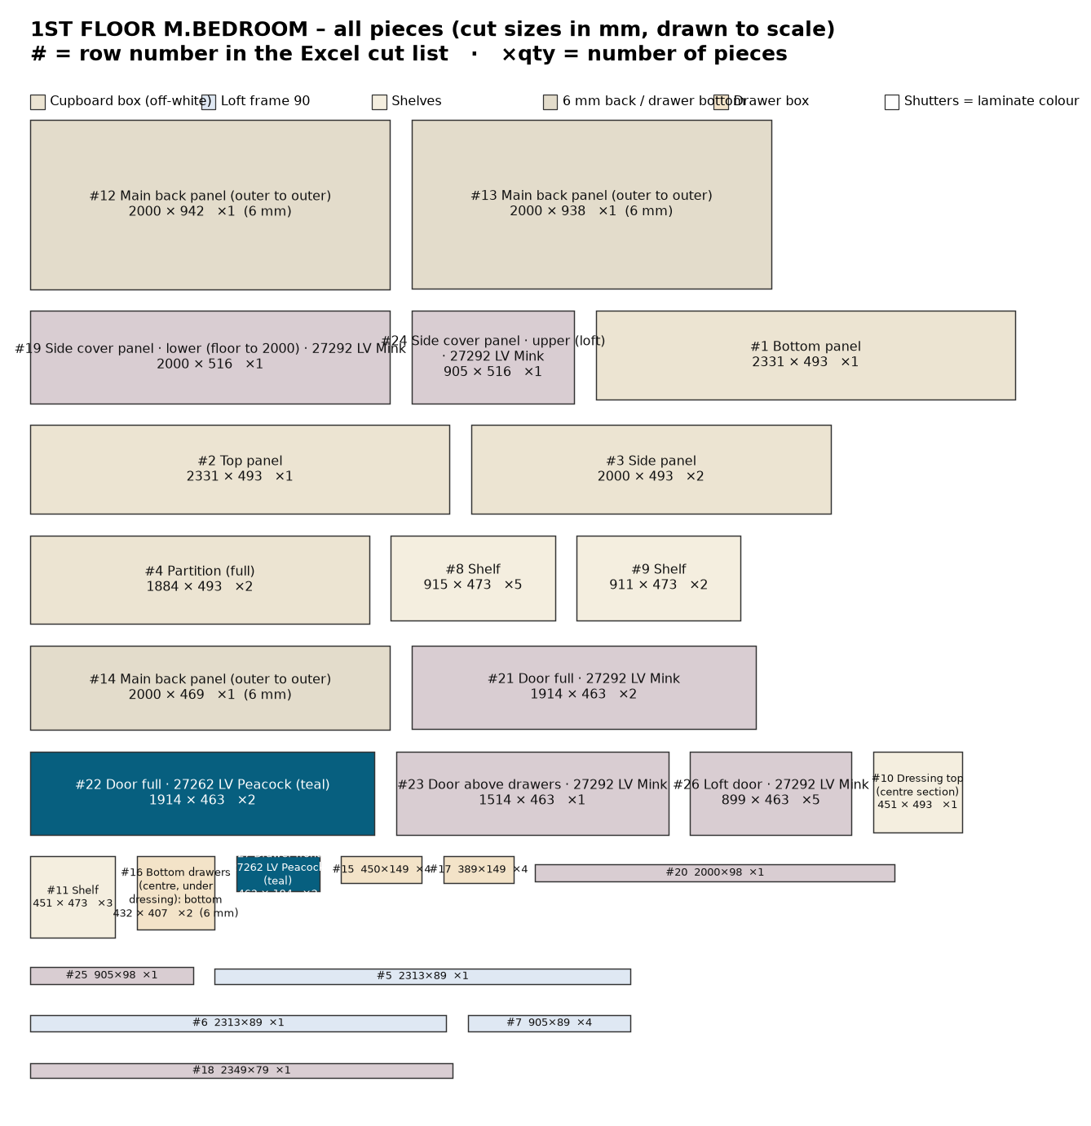

1st Floor M.Bedroom wardrobe – cut list
# | Group | Part | Material | Qty | Finished L | Finished W | Cut L | Cut W | Edge band | Machining / note
Cupboard box
1 | Cupboard box | Bottom panel | 18 mm ply | 1 | 2331 | 494 | 2331 | 493 | 0.5 mm, 1 long
2 | Cupboard box | Top panel | 18 mm ply | 1 | 2331 | 494 | 2331 | 493 | 0.5 mm, 1 long
3 | Cupboard box | Side panel (cupboard, 2000 high) | 18 mm ply | 2 | 2000 | 494 | 2000 | 493 | 0.5 mm, 1 long | 6 mm back screwed on back edge
4 | Cupboard box | Partition (full height, doors fixed) | 18 mm ply | 2 | 1884 | 494 | 1884 | 493 | 0.5 mm, 1 long | back panel joint on its back edge (centre)
Loft frame 90 mm
5 | Loft frame 90 mm | Top rail | 18 mm ply | 1 | 2313 | 90 | 2313 | 89 | 0.5 mm, 1 long | fix to ceiling
6 | Loft frame 90 mm | Bottom rail (front, on cupboard top) | 18 mm ply | 1 | 2313 | 90 | 2313 | 89 | 0.5 mm, 1 long
7 | Loft frame 90 mm | Frame upright (end / partition) | 18 mm ply | 4 | 905 | 90 | 905 | 89 | 0.5 mm, 1 long | loft frame only - no box, no back panel
Inside
8 | Inside | Shelf | 18 mm ply | 5 | 915 | 474 | 915 | 473 | 0.5 mm, 1 long
9 | Inside | Shelf | 18 mm ply | 2 | 911 | 474 | 911 | 473 | 0.5 mm, 1 long
10 | Inside | Dressing top (centre section) | 18 mm ply | 1 | 451 | 494 | 451 | 493 | 0.5 mm, 1 long | flush with front (behind door 3); top 800 from floor; mirror + LED above
11 | Inside | Shelf | 18 mm ply | 3 | 451 | 474 | 451 | 473 | 0.5 mm, 1 long
Back panels 6 mm
12 | Back panels 6 mm | Main back panel (outer to outer) | 6 mm back ply | 1 | 2000 | 942 | 2000 | 942 | - | screw on back edges of sides / top / bottom / partitions; joint on partition centre
13 | Back panels 6 mm | Main back panel (outer to outer) | 6 mm back ply | 1 | 2000 | 938 | 2000 | 938 | - | screw on back edges of sides / top / bottom / partitions; joint on partition centre
14 | Back panels 6 mm | Main back panel (outer to outer) | 6 mm back ply | 1 | 2000 | 469 | 2000 | 469 | - | screw on back edges of sides / top / bottom / partitions; joint on partition centre
Drawers
15 | Drawers | Bottom drawers (centre, under dressing): drawer side | 18 mm ply | 4 | 450 | 150 | 450 | 149 | 0.5 mm, 1 long | groove 8 mm wide x 10 deep: leave 12 mm from bottom edge, groove 12-20 mm (6 mm drawer bottom slides in)
16 | Drawers | Bottom drawers (centre, under dressing): drawer bottom 6 mm (in groove) | 6 mm back ply | 2 | 432 | 407 | 432 | 407 | - | inside size + 9 mm each side (10 mm groove, 1 mm play)
17 | Drawers | Bottom drawers (centre, under dressing): drawer front/back inner | 18 mm ply | 4 | 389 | 150 | 389 | 149 | 0.5 mm, 1 long | groove 8 mm wide x 10 deep: leave 12 mm from bottom edge, groove 12-20 mm (6 mm drawer bottom slides in)
Shutters
18 | Shutters | Skirting (front, base 80) - 27292 LV Mink (grey) | 18 mm ply + Merino laminate (shutter) | 1 | 2349 | 80 | 2349 | 79 | 0.5 mm, 1 long | full base height 80 (doors start 1.5 above); 0.5 mm tape on top edge only
19 | Shutters | Side cover panel - lower (floor to 2000) - 27292 LV Mink (grey) | 18 mm ply + Merino laminate (shutter) | 1 | 2000 | 518 | 2000 | 516 | 2 mm, 1 long | LEFT end only, outside of side panel; 518 deep = box 500 + door 18; joint in line with door gap
20 | Shutters | Wall-side strip 100 - lower (floor to 2000) - 27292 LV Mink (grey) | 18 mm ply + Merino laminate (shutter) | 1 | 2000 | 100 | 2000 | 98 | 2 mm, 1 long | RIGHT end, outside of side panel at the front (flush with door front); joint in line with door gap
21 | Shutters | Door (full height) - 27292 LV Mink (grey) | 18 mm ply + Merino laminate (shutter) | 2 | 1918 | 467 | 1914 | 463 | 2 mm, 4 sides | concealed hinges; gaps: 2 mm between doors, 3 mm at end, 1 mm bottom, 2 mm to loft door
22 | Shutters | Door (full height) - 27262 LV Peacock (teal) | 18 mm ply + Merino laminate (shutter) | 2 | 1918 | 467 | 1914 | 463 | 2 mm, 4 sides | concealed hinges; gaps: 2 mm between doors, 3 mm at end, 1 mm bottom, 2 mm to loft door
23 | Shutters | Door above drawers - 27292 LV Mink (grey) | 18 mm ply + Merino laminate (shutter) | 1 | 1518 | 467 | 1514 | 463 | 2 mm, 4 sides | concealed hinges; gaps: 2 mm between doors, 3 mm at end, 1 mm bottom, 2 mm to loft door
24 | Shutters | Side cover panel - upper (loft) - 27292 LV Mink (grey) | 18 mm ply + Merino laminate (shutter) | 1 | 905 | 518 | 905 | 516 | 2 mm, 1 long | LEFT end only, outside of side panel; 518 deep = box 500 + door 18; joint in line with door gap
25 | Shutters | Wall-side strip 100 - upper (loft) - 27292 LV Mink (grey) | 18 mm ply + Merino laminate (shutter) | 1 | 905 | 100 | 905 | 98 | 2 mm, 1 long | RIGHT end, outside of side panel at the front (flush with door front); joint in line with door gap
26 | Shutters | Loft door - 27292 LV Mink (grey) | 18 mm ply + Merino laminate (shutter) | 5 | 903 | 467 | 899 | 463 | 2 mm, 4 sides | on loft frame; same width as doors below; 2 mm to cupboard door, 1 mm at top
27 | Shutters | Drawer outside front - 27262 LV Peacock (teal) | 18 mm ply + Merino laminate (shutter) | 2 | 467 | 198 | 463 | 194 | 2 mm, 4 sides | fix on drawer box; handle
 |  | Total pieces |  | 53

Material | Area sq.ft / length | 8×4 sheets (15% waste) | Hardware / item
18 mm ply | 121.4 | 5 | LED strip light + aluminium profile (in grooves): 3 pcs, 4.87 m total
6 mm back ply | 54.4 | 2 | LED driver + door sensor switch: 1
18 mm ply + Merino laminate (shutter) | 92.2 | 4 | Soft-close telescopic channels 450 mm (pairs): 2
Edge tape 0.5 mm (front edges) | 39 m |  | Drawer handles / profile: 2
Edge tape 2 mm (shutters, 4 sides) | 50 m |  | Concealed soft-close hinges (doors): 39
 |  |  | Door handles: 5
 |  |  | Dressing mirror 5 mm (on back panel), 341 x 700: 1
 |  |  | Coat stand: oval SS hanging rod 909 long + 2 end brackets (rod 1609 from floor, 1200 hanging): 1

LED strip light – profile groove cutting
Groove 12 mm wide × 8 mm deep, 100 mm from the front edge, vertical, on the panel face inside the section. Start is measured from the top of the bottom panel; groove runs up to the underside of the top panel. Drill a 10 mm wire hole through the top panel at the groove top. Keep shelf screws clear of the groove.
Section | Opening W | Panel | Groove on | From front | Groove start | Groove length | Profile + strip
1 | 911 | Side panel | right face (inside section) | 100 mm | 0 mm | 1884 mm | 1864 mm
2 | 451 | Partition | right face (inside section) | 100 mm | 720 mm (above drawers) | 1164 mm | 1144 mm
3 | 915 | Partition | right face (inside section) | 100 mm | 0 mm | 1884 mm | 1864 mm
Total |  |  |  |  |  |  | 4.87 m

1st Floor Bedroom 2 wardrobe
2319 W × 2895 H × 500 D · cupboard box 2000 mm + loft 90 mm frame only · cupboard clear 1884 mm
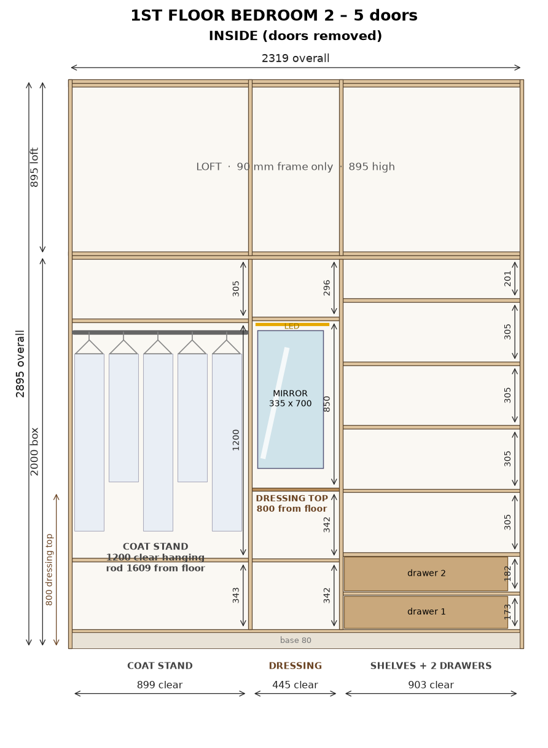
2D drawing (owner's AutoCAD): cupboard box 2000 mm high; loft above = 90 mm frame only (uprights + top/bottom rails). LED strip groove in each cupboard section.

1st Floor Bedroom 2 – shutters with Merino laminate
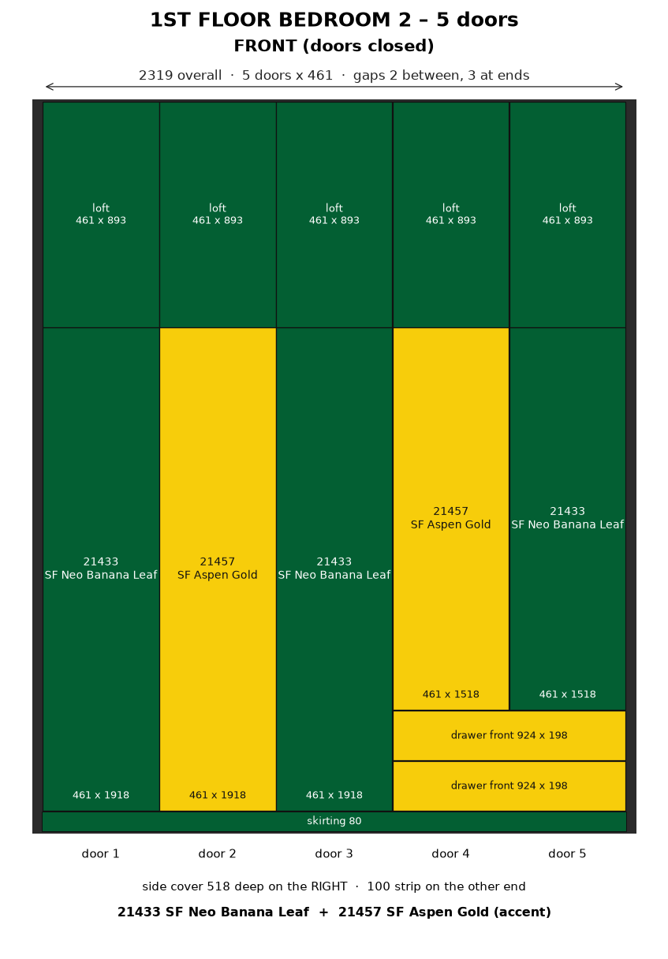

1st Floor Bedroom 2 – 3D model – assembled box without doors (off-white carcass, LED strips, drawer fronts)
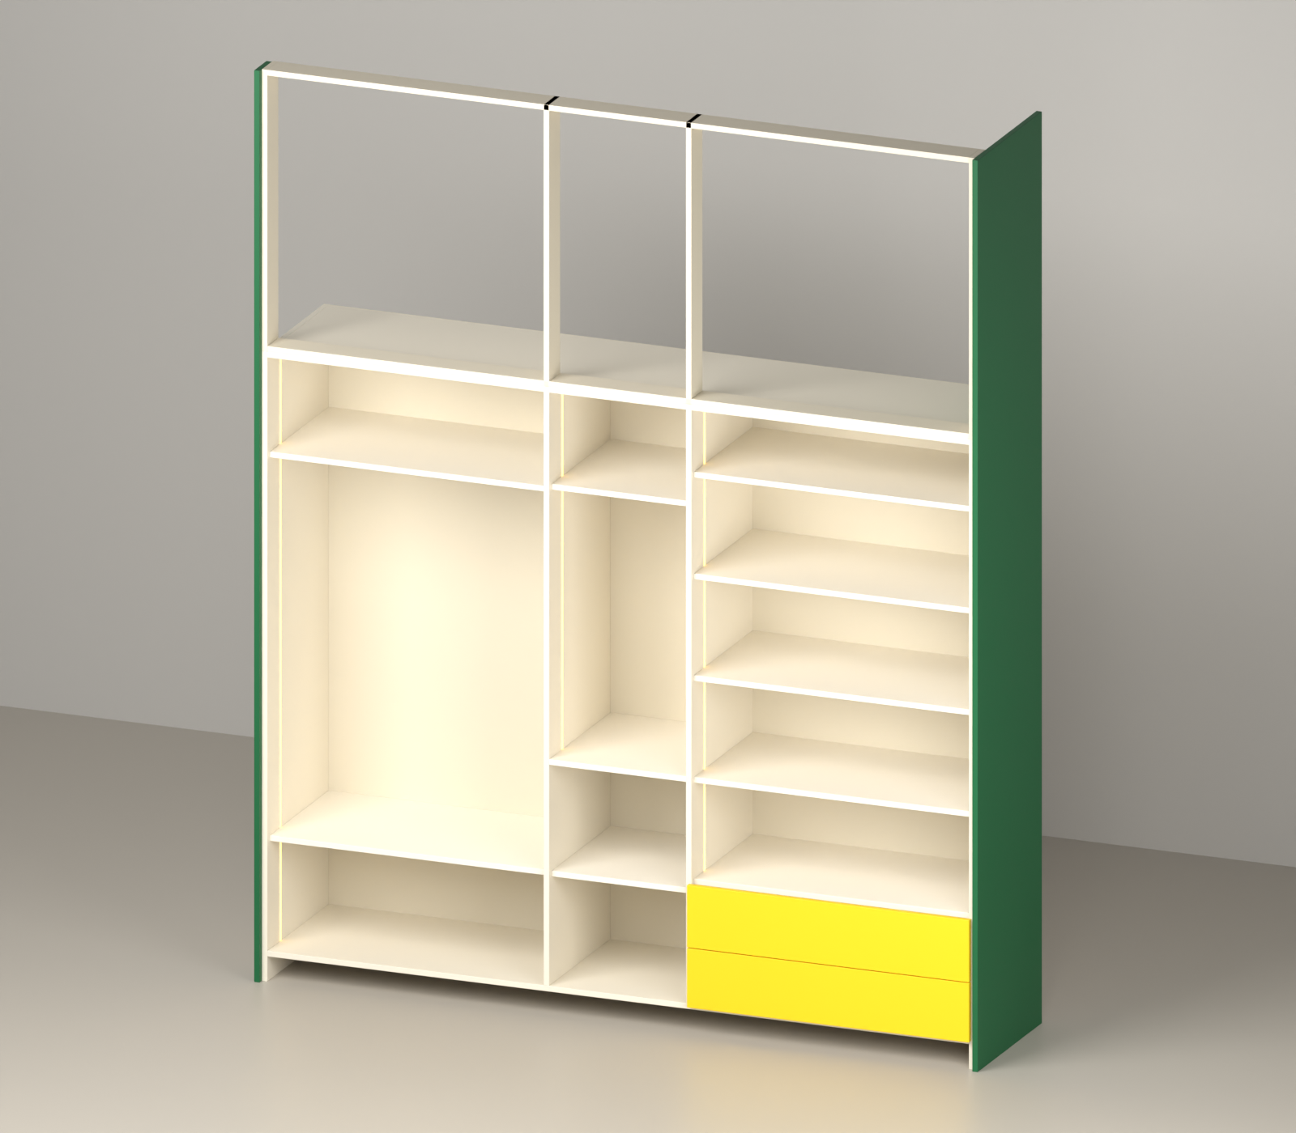

1st Floor Bedroom 2 – 3D model – exploded view of the pieces
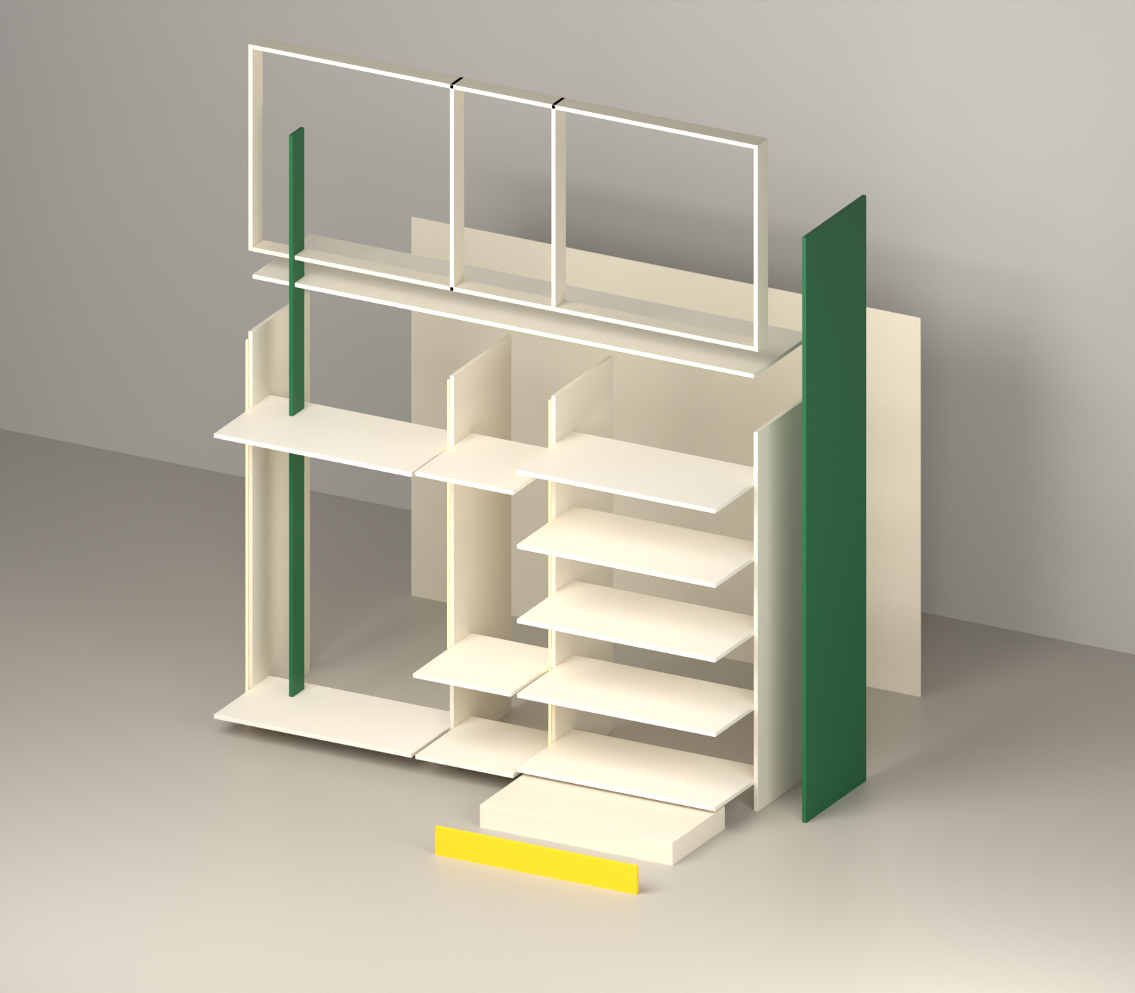

1st Floor Bedroom 2 – All pieces drawn to scale – # = row number in the cut list
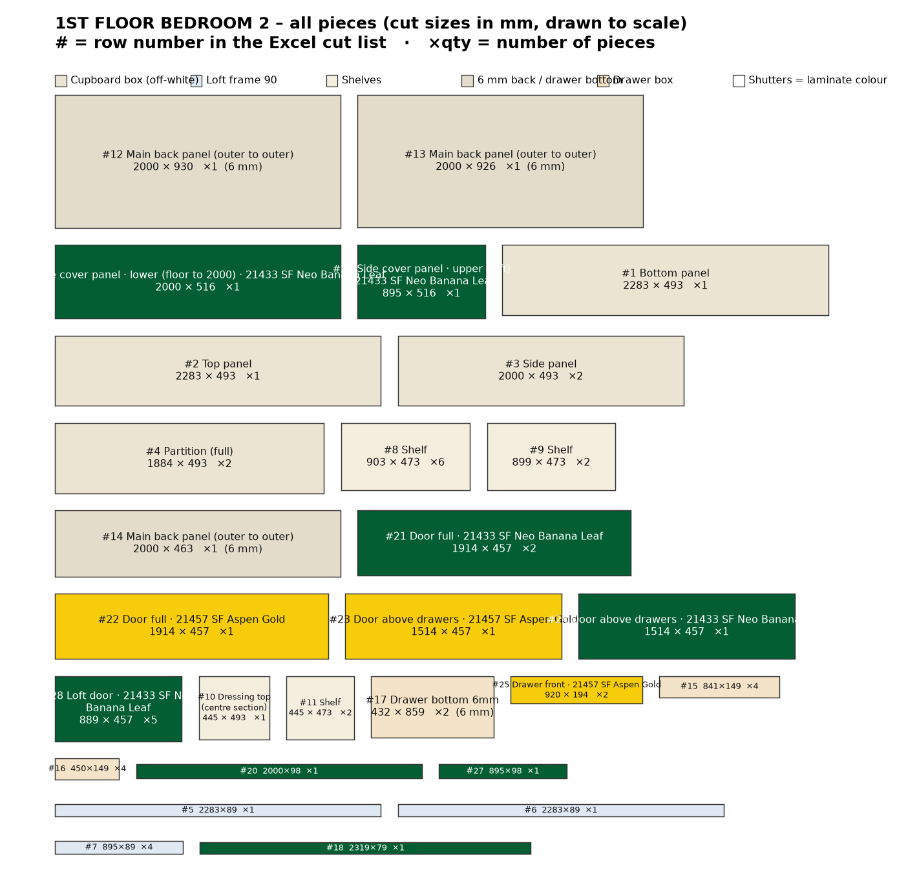

1st Floor Bedroom 2 wardrobe – cut list
# | Group | Part | Material | Qty | Finished L | Finished W | Cut L | Cut W | Edge band | Machining / note
Cupboard box
1 | Cupboard box | Bottom panel | 18 mm ply | 1 | 2283 | 494 | 2283 | 493 | 0.5 mm, 1 long
2 | Cupboard box | Top panel | 18 mm ply | 1 | 2283 | 494 | 2283 | 493 | 0.5 mm, 1 long
3 | Cupboard box | Side panel (cupboard, 2000 high) | 18 mm ply | 2 | 2000 | 494 | 2000 | 493 | 0.5 mm, 1 long | 6 mm back screwed on back edge
4 | Cupboard box | Partition (full height, doors fixed) | 18 mm ply | 2 | 1884 | 494 | 1884 | 493 | 0.5 mm, 1 long | back panel joint on its back edge (centre)
Loft frame 90 mm
5 | Loft frame 90 mm | Top rail | 18 mm ply | 1 | 2283 | 90 | 2283 | 89 | 0.5 mm, 1 long | fix to ceiling
6 | Loft frame 90 mm | Bottom rail (front, on cupboard top) | 18 mm ply | 1 | 2283 | 90 | 2283 | 89 | 0.5 mm, 1 long
7 | Loft frame 90 mm | Frame upright (end / partition) | 18 mm ply | 4 | 895 | 90 | 895 | 89 | 0.5 mm, 1 long | loft frame only - no box, no back panel
Inside
8 | Inside | Shelf | 18 mm ply | 6 | 903 | 474 | 903 | 473 | 0.5 mm, 1 long
9 | Inside | Shelf | 18 mm ply | 2 | 899 | 474 | 899 | 473 | 0.5 mm, 1 long
10 | Inside | Dressing top (centre section) | 18 mm ply | 1 | 445 | 494 | 445 | 493 | 0.5 mm, 1 long | flush with front (behind door 3); top 800 from floor; mirror + LED above
11 | Inside | Shelf | 18 mm ply | 2 | 445 | 474 | 445 | 473 | 0.5 mm, 1 long
Back panels 6 mm
12 | Back panels 6 mm | Main back panel (outer to outer) | 6 mm back ply | 1 | 2000 | 930 | 2000 | 930 | - | screw on back edges of sides / top / bottom / partitions; joint on partition centre
13 | Back panels 6 mm | Main back panel (outer to outer) | 6 mm back ply | 1 | 2000 | 926 | 2000 | 926 | - | screw on back edges of sides / top / bottom / partitions; joint on partition centre
14 | Back panels 6 mm | Main back panel (outer to outer) | 6 mm back ply | 1 | 2000 | 463 | 2000 | 463 | - | screw on back edges of sides / top / bottom / partitions; joint on partition centre
Drawers
15 | Drawers | Bottom drawers (right section): drawer front/back inner | 18 mm ply | 4 | 841 | 150 | 841 | 149 | 0.5 mm, 1 long | groove 8 mm wide x 10 deep: leave 12 mm from bottom edge, groove 12-20 mm (6 mm drawer bottom slides in)
16 | Drawers | Bottom drawers (right section): drawer side | 18 mm ply | 4 | 450 | 150 | 450 | 149 | 0.5 mm, 1 long | groove 8 mm wide x 10 deep: leave 12 mm from bottom edge, groove 12-20 mm (6 mm drawer bottom slides in)
17 | Drawers | Bottom drawers (right section): drawer bottom 6 mm (in groove) | 6 mm back ply | 2 | 432 | 859 | 432 | 859 | - | inside size + 9 mm each side (10 mm groove, 1 mm play)
Shutters
18 | Shutters | Skirting (front, base 80) - 21433 SF Neo Banana Leaf (green) | 18 mm ply + Merino laminate (shutter) | 1 | 2319 | 80 | 2319 | 79 | 0.5 mm, 1 long | full base height 80 (doors start 1.5 above); 0.5 mm tape on top edge only
19 | Shutters | Side cover panel - lower (floor to 2000) - 21433 SF Neo Banana Leaf (green) | 18 mm ply + Merino laminate (shutter) | 1 | 2000 | 518 | 2000 | 516 | 2 mm, 1 long | RIGHT end only, outside of side panel; 518 deep = box 500 + door 18; joint in line with door gap
20 | Shutters | Wall-side strip 100 - lower (floor to 2000) - 21433 SF Neo Banana Leaf (green) | 18 mm ply + Merino laminate (shutter) | 1 | 2000 | 100 | 2000 | 98 | 2 mm, 1 long | LEFT end, outside of side panel at the front (flush with door front); joint in line with door gap
21 | Shutters | Door (full height) - 21433 SF Neo Banana Leaf (green) | 18 mm ply + Merino laminate (shutter) | 2 | 1918 | 461 | 1914 | 457 | 2 mm, 4 sides | concealed hinges; gaps: 2 mm between doors, 3 mm at end, 1 mm bottom, 2 mm to loft door
22 | Shutters | Door (full height) - 21457 SF Aspen Gold (yellow) | 18 mm ply + Merino laminate (shutter) | 1 | 1918 | 461 | 1914 | 457 | 2 mm, 4 sides | concealed hinges; gaps: 2 mm between doors, 3 mm at end, 1 mm bottom, 2 mm to loft door
23 | Shutters | Door above drawers - 21457 SF Aspen Gold (yellow) | 18 mm ply + Merino laminate (shutter) | 1 | 1518 | 461 | 1514 | 457 | 2 mm, 4 sides | concealed hinges; gaps: 2 mm between doors, 3 mm at end, 1 mm bottom, 2 mm to loft door
24 | Shutters | Door above drawers - 21433 SF Neo Banana Leaf (green) | 18 mm ply + Merino laminate (shutter) | 1 | 1518 | 461 | 1514 | 457 | 2 mm, 4 sides | concealed hinges; gaps: 2 mm between doors, 3 mm at end, 1 mm bottom, 2 mm to loft door
25 | Shutters | Drawer outside front - 21457 SF Aspen Gold (yellow) | 18 mm ply + Merino laminate (shutter) | 2 | 924 | 198 | 920 | 194 | 2 mm, 4 sides | fix on drawer box; handle
26 | Shutters | Side cover panel - upper (loft) - 21433 SF Neo Banana Leaf (green) | 18 mm ply + Merino laminate (shutter) | 1 | 895 | 518 | 895 | 516 | 2 mm, 1 long | RIGHT end only, outside of side panel; 518 deep = box 500 + door 18; joint in line with door gap
27 | Shutters | Wall-side strip 100 - upper (loft) - 21433 SF Neo Banana Leaf (green) | 18 mm ply + Merino laminate (shutter) | 1 | 895 | 100 | 895 | 98 | 2 mm, 1 long | LEFT end, outside of side panel at the front (flush with door front); joint in line with door gap
28 | Shutters | Loft door - 21433 SF Neo Banana Leaf (green) | 18 mm ply + Merino laminate (shutter) | 5 | 893 | 461 | 889 | 457 | 2 mm, 4 sides | on loft frame; same width as doors below; 2 mm to cupboard door, 1 mm at top
 |  | Total pieces |  | 53

Material | Area sq.ft / length | 8×4 sheets (15% waste) | Hardware / item
18 mm ply | 125.5 | 5 | LED strip light + aluminium profile (in grooves): 3 pcs, 4.48 m total
6 mm back ply | 57.9 | 3 | LED driver + door sensor switch: 1
18 mm ply + Merino laminate (shutter) | 91.0 | 4 | Soft-close telescopic channels 450 mm (pairs): 2
Edge tape 0.5 mm (front edges) | 41 m |  | Drawer handles / profile: 2
Edge tape 2 mm (shutters, 4 sides) | 51 m |  | Concealed soft-close hinges (doors): 33
 |  |  | Door handles: 5
 |  |  | Dressing mirror 5 mm (on back panel), 335 x 700: 1
 |  |  | Coat stand: oval SS hanging rod 897 long + 2 end brackets (rod 1609 from floor, 1200 hanging): 1

LED strip light – profile groove cutting
Groove 12 mm wide × 8 mm deep, 100 mm from the front edge, vertical, on the panel face inside the section. Start is measured from the top of the bottom panel; groove runs up to the underside of the top panel. Drill a 10 mm wire hole through the top panel at the groove top. Keep shelf screws clear of the groove.
Section | Opening W | Panel | Groove on | From front | Groove start | Groove length | Profile + strip
1 | 899 | Side panel | right face (inside section) | 100 mm | 0 mm | 1884 mm | 1864 mm
2 | 445 | Partition | right face (inside section) | 100 mm | 720 mm (above drawers) | 1164 mm | 1144 mm
3 | 903 | Partition | right face (inside section) | 100 mm | 391 mm (above drawers) | 1493 mm | 1473 mm
Total |  |  |  |  |  |  | 4.48 m

2nd Floor Bedroom wardrobe
2349 W × 2825 H × 500 D · cupboard box 2000 mm + loft 90 mm frame only · cupboard clear 1884 mm
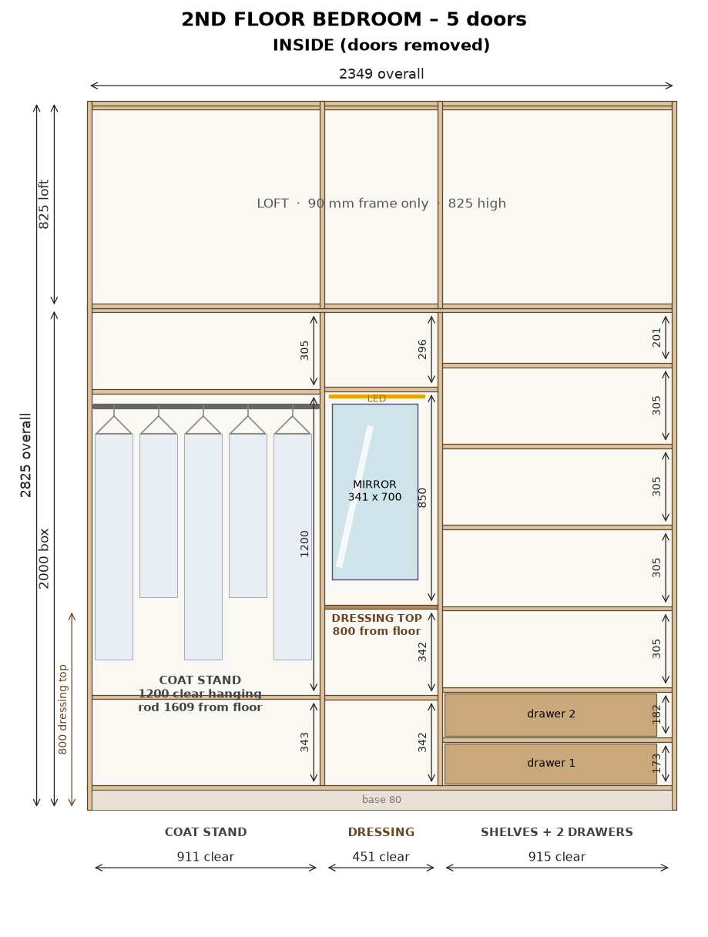
2D drawing (owner's AutoCAD): cupboard box 2000 mm high; loft above = 90 mm frame only (uprights + top/bottom rails). LED strip groove in each cupboard section.

2nd Floor Bedroom – shutters with Merino laminate
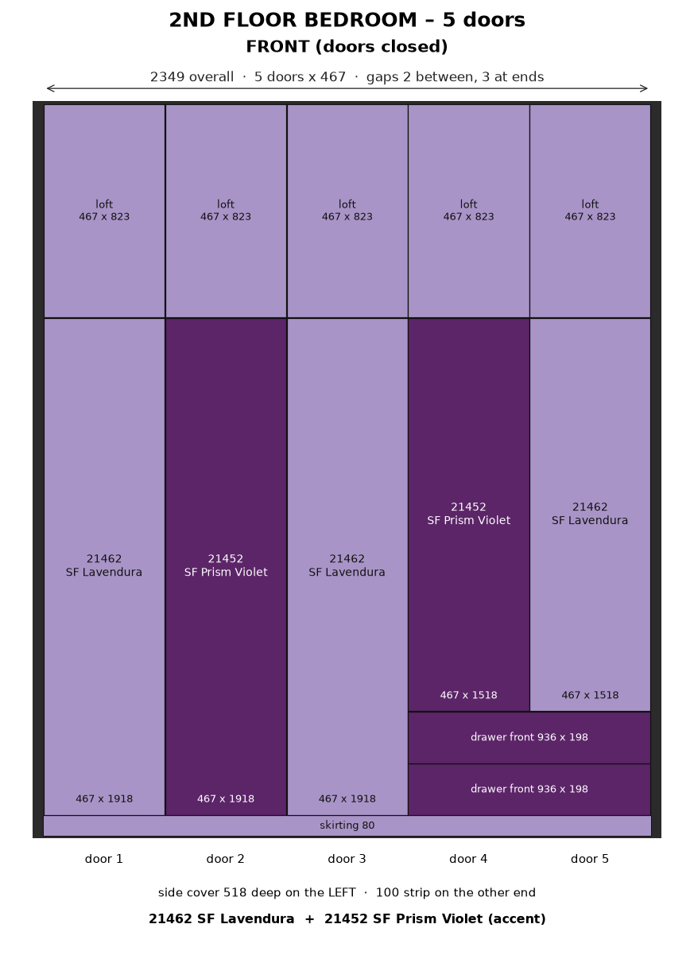

2nd Floor Bedroom – 3D model – assembled box without doors (off-white carcass, LED strips, drawer fronts)
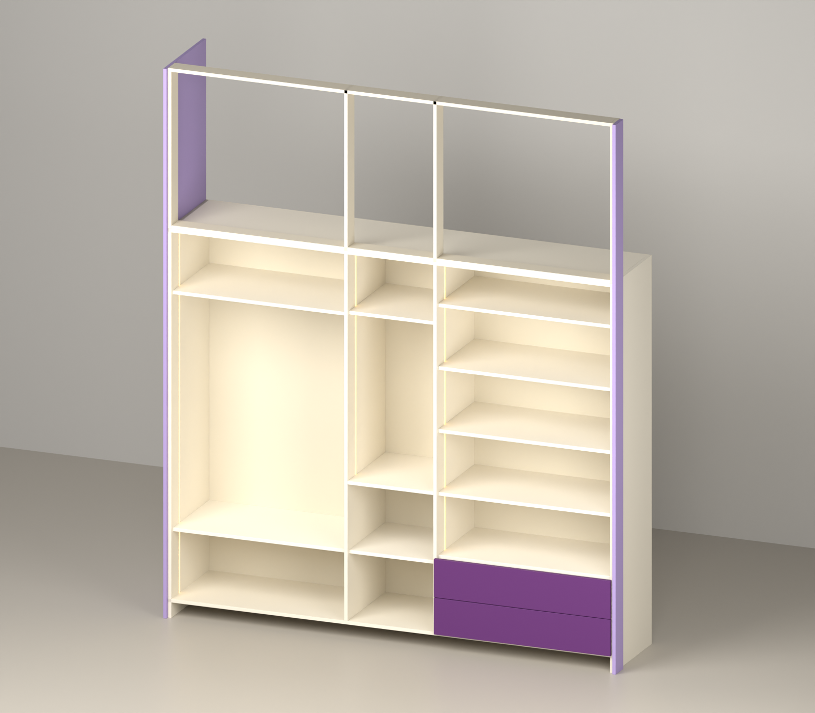

2nd Floor Bedroom – 3D model – exploded view of the pieces
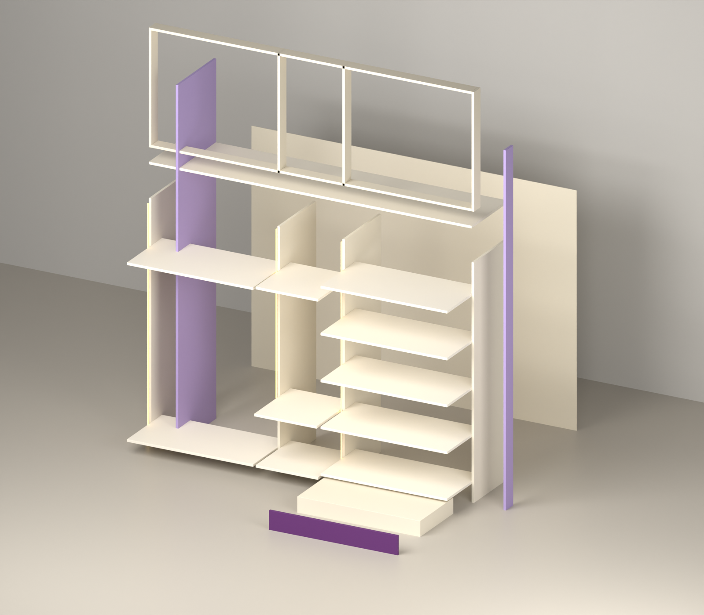

2nd Floor Bedroom – All pieces drawn to scale – # = row number in the cut list
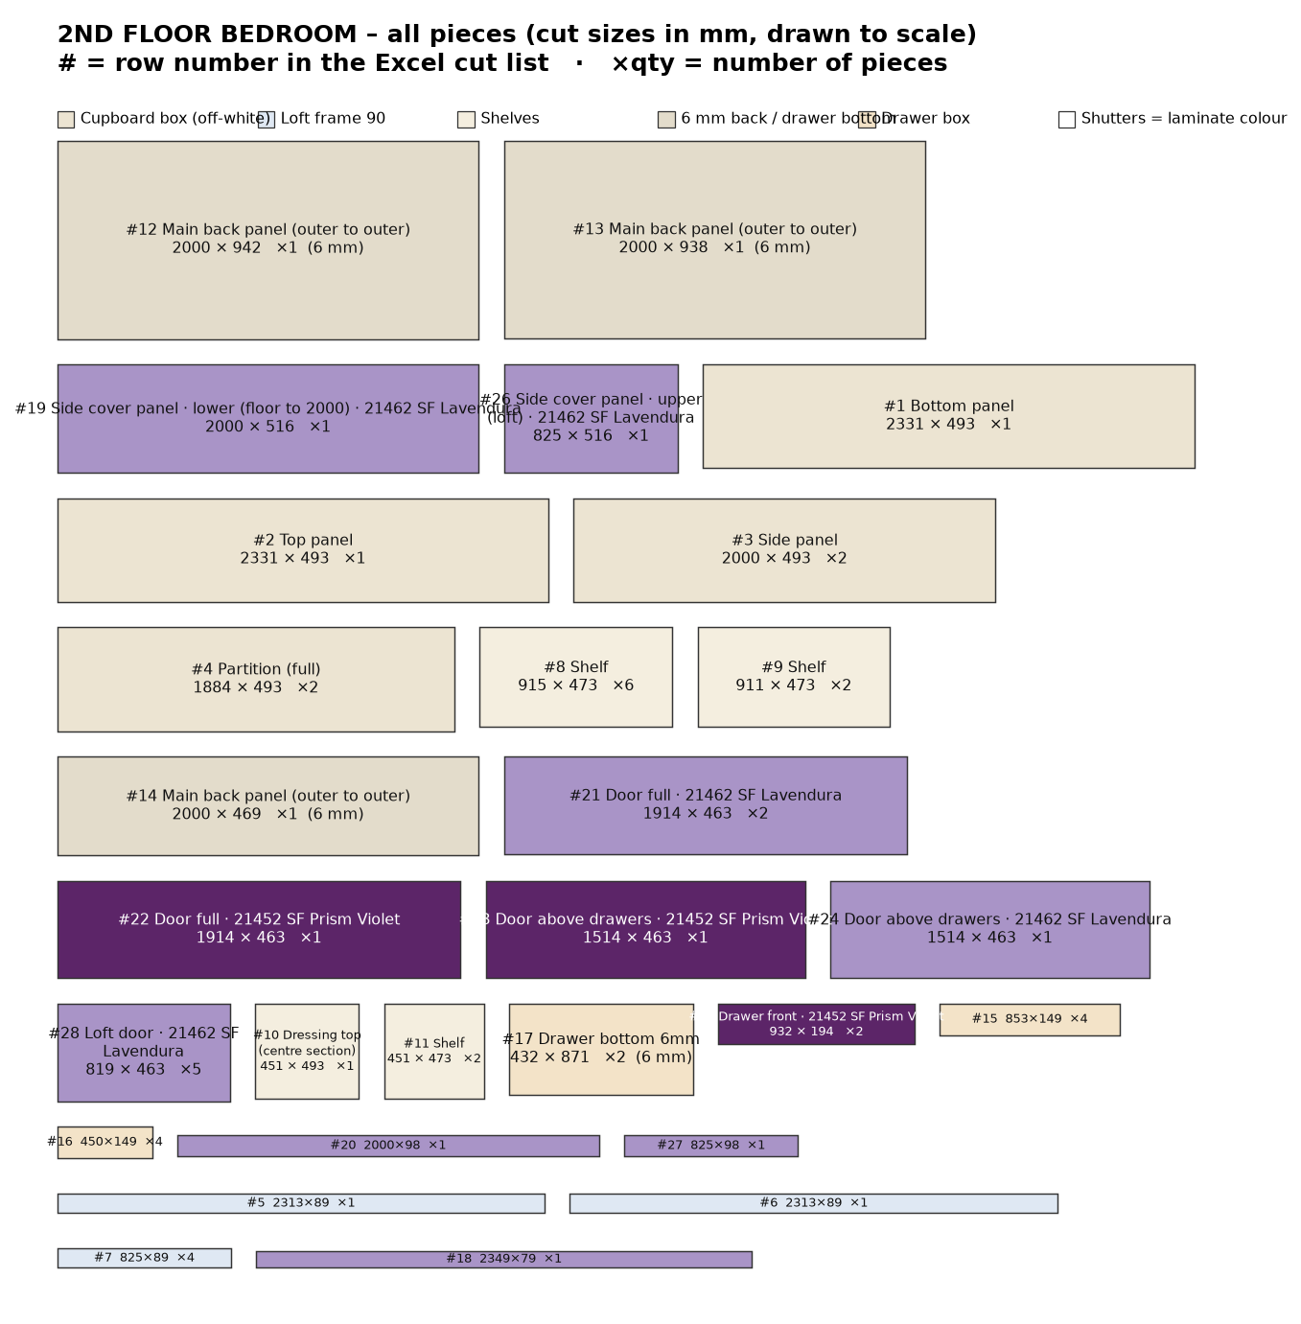

2nd Floor Bedroom wardrobe – cut list
# | Group | Part | Material | Qty | Finished L | Finished W | Cut L | Cut W | Edge band | Machining / note
Cupboard box
1 | Cupboard box | Bottom panel | 18 mm ply | 1 | 2331 | 494 | 2331 | 493 | 0.5 mm, 1 long
2 | Cupboard box | Top panel | 18 mm ply | 1 | 2331 | 494 | 2331 | 493 | 0.5 mm, 1 long
3 | Cupboard box | Side panel (cupboard, 2000 high) | 18 mm ply | 2 | 2000 | 494 | 2000 | 493 | 0.5 mm, 1 long | 6 mm back screwed on back edge
4 | Cupboard box | Partition (full height, doors fixed) | 18 mm ply | 2 | 1884 | 494 | 1884 | 493 | 0.5 mm, 1 long | back panel joint on its back edge (centre)
Loft frame 90 mm
5 | Loft frame 90 mm | Top rail | 18 mm ply | 1 | 2313 | 90 | 2313 | 89 | 0.5 mm, 1 long | fix to ceiling
6 | Loft frame 90 mm | Bottom rail (front, on cupboard top) | 18 mm ply | 1 | 2313 | 90 | 2313 | 89 | 0.5 mm, 1 long
7 | Loft frame 90 mm | Frame upright (end / partition) | 18 mm ply | 4 | 825 | 90 | 825 | 89 | 0.5 mm, 1 long | loft frame only - no box, no back panel
Inside
8 | Inside | Shelf | 18 mm ply | 6 | 915 | 474 | 915 | 473 | 0.5 mm, 1 long
9 | Inside | Shelf | 18 mm ply | 2 | 911 | 474 | 911 | 473 | 0.5 mm, 1 long
10 | Inside | Dressing top (centre section) | 18 mm ply | 1 | 451 | 494 | 451 | 493 | 0.5 mm, 1 long | flush with front (behind door 3); top 800 from floor; mirror + LED above
11 | Inside | Shelf | 18 mm ply | 2 | 451 | 474 | 451 | 473 | 0.5 mm, 1 long
Back panels 6 mm
12 | Back panels 6 mm | Main back panel (outer to outer) | 6 mm back ply | 1 | 2000 | 942 | 2000 | 942 | - | screw on back edges of sides / top / bottom / partitions; joint on partition centre
13 | Back panels 6 mm | Main back panel (outer to outer) | 6 mm back ply | 1 | 2000 | 938 | 2000 | 938 | - | screw on back edges of sides / top / bottom / partitions; joint on partition centre
14 | Back panels 6 mm | Main back panel (outer to outer) | 6 mm back ply | 1 | 2000 | 469 | 2000 | 469 | - | screw on back edges of sides / top / bottom / partitions; joint on partition centre
Drawers
15 | Drawers | Bottom drawers (right section): drawer front/back inner | 18 mm ply | 4 | 853 | 150 | 853 | 149 | 0.5 mm, 1 long | groove 8 mm wide x 10 deep: leave 12 mm from bottom edge, groove 12-20 mm (6 mm drawer bottom slides in)
16 | Drawers | Bottom drawers (right section): drawer side | 18 mm ply | 4 | 450 | 150 | 450 | 149 | 0.5 mm, 1 long | groove 8 mm wide x 10 deep: leave 12 mm from bottom edge, groove 12-20 mm (6 mm drawer bottom slides in)
17 | Drawers | Bottom drawers (right section): drawer bottom 6 mm (in groove) | 6 mm back ply | 2 | 432 | 871 | 432 | 871 | - | inside size + 9 mm each side (10 mm groove, 1 mm play)
Shutters
18 | Shutters | Skirting (front, base 80) - 21462 SF Lavendura (lavender) | 18 mm ply + Merino laminate (shutter) | 1 | 2349 | 80 | 2349 | 79 | 0.5 mm, 1 long | full base height 80 (doors start 1.5 above); 0.5 mm tape on top edge only
19 | Shutters | Side cover panel - lower (floor to 2000) - 21462 SF Lavendura (lavender) | 18 mm ply + Merino laminate (shutter) | 1 | 2000 | 518 | 2000 | 516 | 2 mm, 1 long | LEFT end only, outside of side panel; 518 deep = box 500 + door 18; joint in line with door gap
20 | Shutters | Wall-side strip 100 - lower (floor to 2000) - 21462 SF Lavendura (lavender) | 18 mm ply + Merino laminate (shutter) | 1 | 2000 | 100 | 2000 | 98 | 2 mm, 1 long | RIGHT end, outside of side panel at the front (flush with door front); joint in line with door gap
21 | Shutters | Door (full height) - 21462 SF Lavendura (lavender) | 18 mm ply + Merino laminate (shutter) | 2 | 1918 | 467 | 1914 | 463 | 2 mm, 4 sides | concealed hinges; gaps: 2 mm between doors, 3 mm at end, 1 mm bottom, 2 mm to loft door
22 | Shutters | Door (full height) - 21452 SF Prism Violet (violet) | 18 mm ply + Merino laminate (shutter) | 1 | 1918 | 467 | 1914 | 463 | 2 mm, 4 sides | concealed hinges; gaps: 2 mm between doors, 3 mm at end, 1 mm bottom, 2 mm to loft door
23 | Shutters | Door above drawers - 21452 SF Prism Violet (violet) | 18 mm ply + Merino laminate (shutter) | 1 | 1518 | 467 | 1514 | 463 | 2 mm, 4 sides | concealed hinges; gaps: 2 mm between doors, 3 mm at end, 1 mm bottom, 2 mm to loft door
24 | Shutters | Door above drawers - 21462 SF Lavendura (lavender) | 18 mm ply + Merino laminate (shutter) | 1 | 1518 | 467 | 1514 | 463 | 2 mm, 4 sides | concealed hinges; gaps: 2 mm between doors, 3 mm at end, 1 mm bottom, 2 mm to loft door
25 | Shutters | Drawer outside front - 21452 SF Prism Violet (violet) | 18 mm ply + Merino laminate (shutter) | 2 | 936 | 198 | 932 | 194 | 2 mm, 4 sides | fix on drawer box; handle
26 | Shutters | Side cover panel - upper (loft) - 21462 SF Lavendura (lavender) | 18 mm ply + Merino laminate (shutter) | 1 | 825 | 518 | 825 | 516 | 2 mm, 1 long | LEFT end only, outside of side panel; 518 deep = box 500 + door 18; joint in line with door gap
27 | Shutters | Wall-side strip 100 - upper (loft) - 21462 SF Lavendura (lavender) | 18 mm ply + Merino laminate (shutter) | 1 | 825 | 100 | 825 | 98 | 2 mm, 1 long | RIGHT end, outside of side panel at the front (flush with door front); joint in line with door gap
28 | Shutters | Loft door - 21462 SF Lavendura (lavender) | 18 mm ply + Merino laminate (shutter) | 5 | 823 | 467 | 819 | 463 | 2 mm, 4 sides | on loft frame; same width as doors below; 2 mm to cupboard door, 1 mm at top
 |  | Total pieces |  | 53

Material | Area sq.ft / length | 8×4 sheets (15% waste) | Hardware / item
18 mm ply | 126.5 | 5 | LED strip light + aluminium profile (in grooves): 3 pcs, 4.48 m total
6 mm back ply | 58.7 | 3 | LED driver + door sensor switch: 1
18 mm ply + Merino laminate (shutter) | 89.7 | 4 | Soft-close telescopic channels 450 mm (pairs): 2
Edge tape 0.5 mm (front edges) | 41 m |  | Drawer handles / profile: 2
Edge tape 2 mm (shutters, 4 sides) | 50 m |  | Concealed soft-close hinges (doors): 33
 |  |  | Door handles: 5
 |  |  | Dressing mirror 5 mm (on back panel), 341 x 700: 1
 |  |  | Coat stand: oval SS hanging rod 909 long + 2 end brackets (rod 1609 from floor, 1200 hanging): 1

LED strip light – profile groove cutting
Groove 12 mm wide × 8 mm deep, 100 mm from the front edge, vertical, on the panel face inside the section. Start is measured from the top of the bottom panel; groove runs up to the underside of the top panel. Drill a 10 mm wire hole through the top panel at the groove top. Keep shelf screws clear of the groove.
Section | Opening W | Panel | Groove on | From front | Groove start | Groove length | Profile + strip
1 | 911 | Side panel | right face (inside section) | 100 mm | 0 mm | 1884 mm | 1864 mm
2 | 451 | Partition | right face (inside section) | 100 mm | 720 mm (above drawers) | 1164 mm | 1144 mm
3 | 915 | Partition | right face (inside section) | 100 mm | 391 mm (above drawers) | 1493 mm | 1473 mm
Total |  |  |  |  |  |  | 4.48 m

